# 02/10/2020 – Project Assignment

This morning (8:30 am) I was assigned to take the lead on the PMC testing project. Insulating the PMC blocks made it more difficult to achieve steady state, so after speaking with Ezra, we think that I way to make the experiment more predictable would be with the addition of a cooling block. Therefore, in this document I will be tracking the progress of the design of this cooling block. First step, acquiring measurements.

I took measurements of every test article. The average dimensions are 101.7 mm length x 50.9 mm width. I designed elected to design the 3d printed part to fit the longest piece: 101.8 mm, so that none of the face of the PMC material is exposed to air during testing.

The cooling blocks will attach to the outside of a ‘PMC sandwich’ where the heating element will be in the middle. See the following image for a more complete picture:

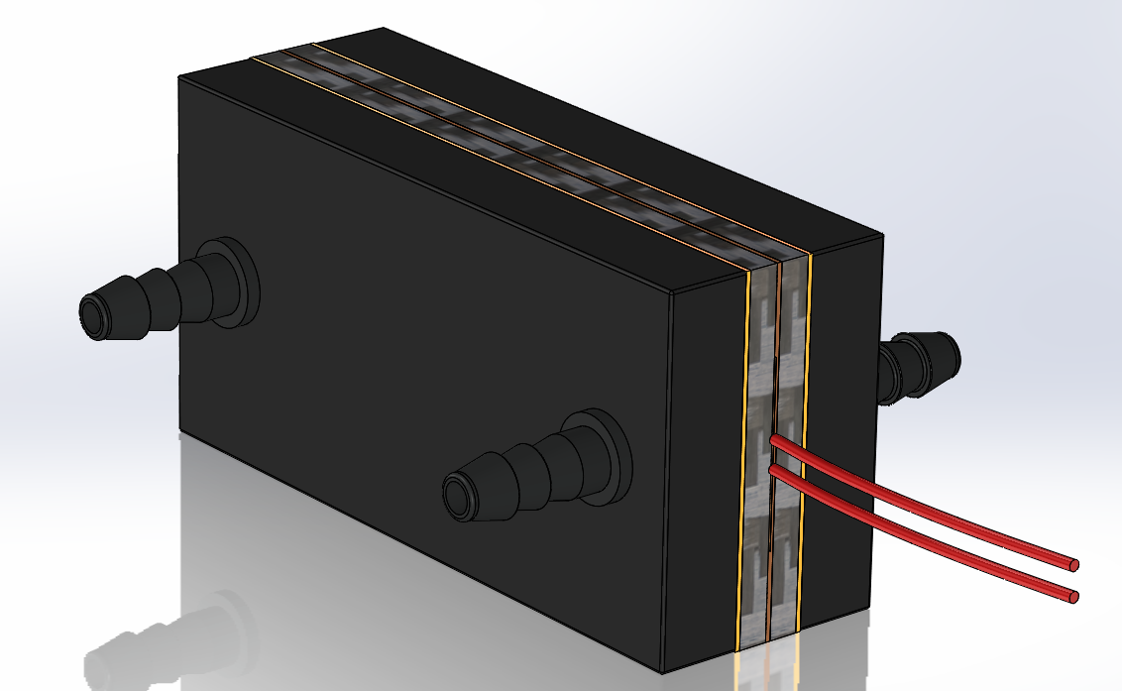

To accommodate the geometry of the tube fittings, custom supports needed to be created:

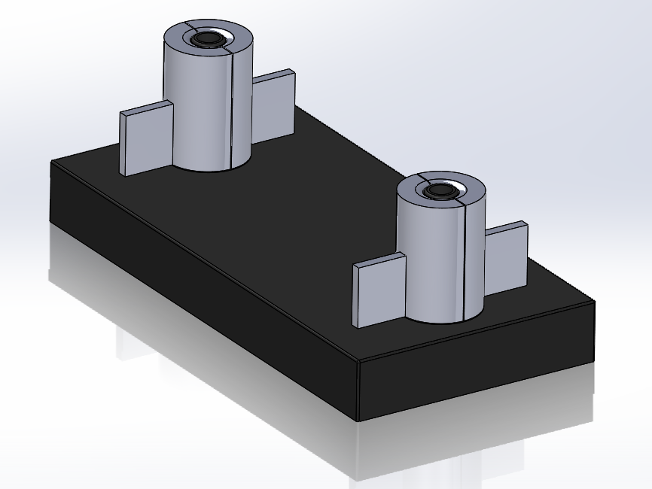

I was unable to start printing today because all of the printers in the I-Lab were in use and the tube fittings require a higher accuracy than the Fortus 250mc can provide.

# 02/20/2020

After running a variety of tests with the insulated cork, we confirmed that the temperature deltas were too small for us to determine an accurate thermal conductivity. Therefore, the cooling block setup is necessary. The cooling blocks have been printed and coated with epoxy to prevent plastic particulates from getting into the recirculator pump. I tested a variety of different epoxies and RTV to bond the copper thermal plates to the onyx plastic, but in the end the best solution (for both a water tight seal and a good bond) was good old super glue.

Today I also created and modelled the design for the stand. It will act like a vice grip and can be clamped or mounted to a test station.

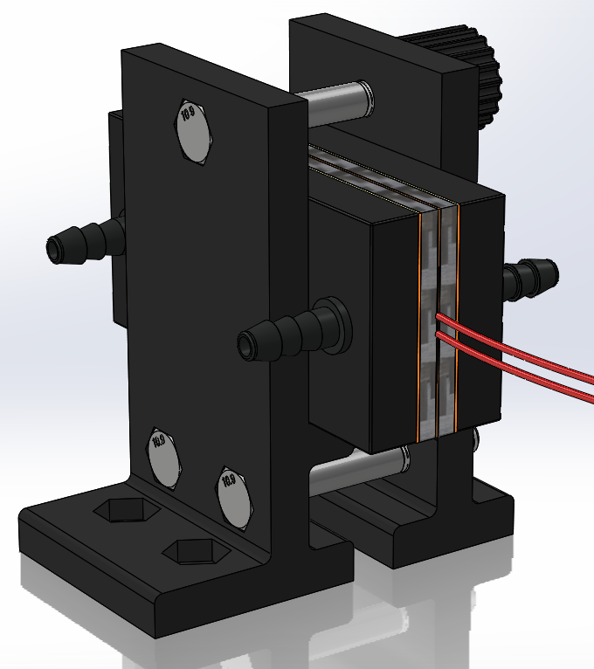

The stand is printing as of this moment (3:50pm 02/20/2020) set to finish tomorrow around noon. The design reuses the hardware I ordered for the heat-pipe test stand, the tube fittings, and the knob assembly.